GenAI Assignment

Name: Yashmitha Shailesh

SRN: PES2UG23CS715

Section: K

EmailID: [yashmithashailesh@gmail.com](mailto:yashmithashailesh@gmail.com)

Mobile number: 8618764905

Github link: <https://github.com/yashmithaa/Genai>

# Assignment 1

**Experiment 1:** Text Generation

Task: Try to generate text using the prompt: "Once upon a time"

Observations:

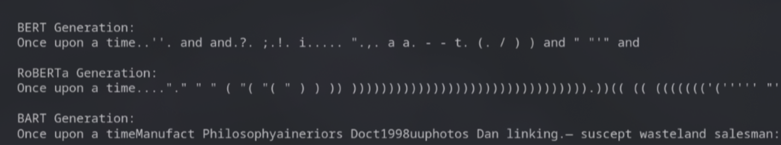

**Experiment 2:** Masked Language Modeling (Missing Word)

Task: Predict the missing word in: "The goal of Generative AI is to [MASK] new content."

Observations:

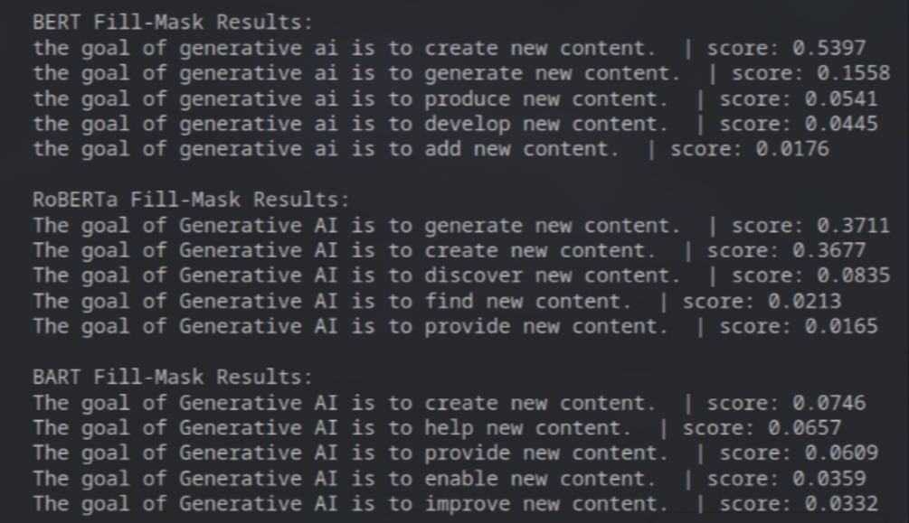

**Experiment 3:** Question Answering

Task: Answer the question "What are the risks?" based on the context: "Generative AI poses significant risks such as hallucinations, bias, and deepfakes."

Observations:

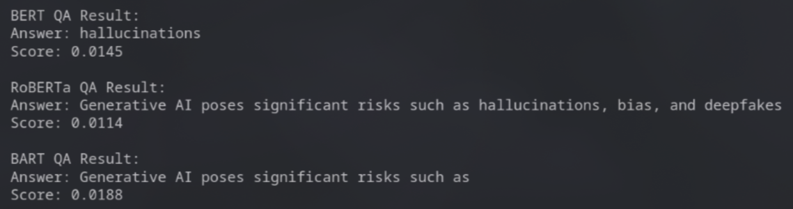

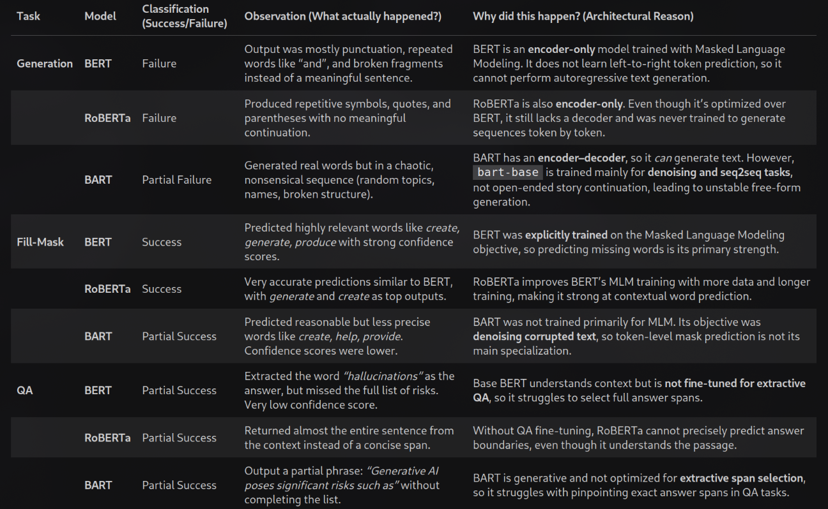

# Assignment 2

**Medical symptom checker**

